

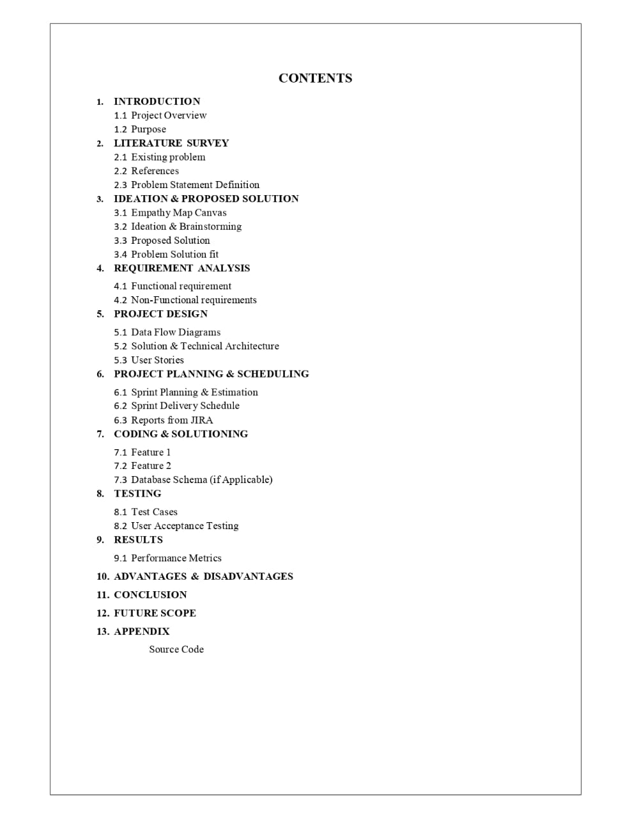

PROJECT REPORT

## INTRODUCTION

* 1. **Project Overview**

Students are often worried about their chances of admission to University.

The aim of this project is to help students in shortlisting universities with their profiles.

The predicted output gives them a fair idea about their admission chances to a particular university.

This analysis should also help students who are currently preparing or will be preparing to get a better idea.

## Purpose

To provide a solution to the students who are in confusion to select the universities for Higher Studies. Our website incorporates an AI Model that was built after considering many leading Machine Learning Algorithms, to provide the most accurate prediction of how much of a chance of admissions does a student’s current grades and other academic transcripts allow them in the tier of universities of their choice but also we provide a single platform that documents all the requirements as well as the different tiers of universities.

## LITERATURE SURVEY

* 1. **Existing Problem**

Students are often worried about their chances of admission to University.

The aim of this project is to help students in shortlisting universities with their profiles.

The predicted output gives them a fair idea about their admission chances to a particular university.

## References

Paper 1 - University Admissions Predictor Publisher -Research Gate

Reference- https://[www.researchgate.net/publication/345391208_University_](http://www.researchgate.net/publication/345391208_University_) Admissions_Predictor

Paper 2 - U Graduate Admission Prediction Using Machine Learning Techniques

Publisher - International Journal of Advanced Research in Science, Engineering and Technology

Reference - <http://www.ijarset.com/upload/2021/july/07-mail2vkk-> 07.PDF

Paper 3- Product Recommendation using Machine Learning Model Publisher - Research Gate

Reference - https://[www.researchgate.net/publication/317399986_Product_](http://www.researchgate.net/publication/317399986_Product_) Recommendation_using_Machine_Learning_Model

Paper 4 - A Review on Data Mining and Machine Learning Methods for Student Scholarship Prediction

Publisher-IEEE

Reference - https://ieeexplore.ieee.org/document/9418376

Paper 5-Survey of Pre-processing Techniques for Mining Big Data Publisher-IEEE

Reference-https://ieeexplore.ieee.org/document/7944072

Paper 6-Data Science – Cosmic Info set Mining, Modeling and Visualization

Publisher-IEEE

Reference-https://ieeexplore.ieee.org/document/8674138

Paper 7-A University Admission Prediction System using Stacked Ensemble Learning

Publisher-IEEE

Reference-https://ieeexplore.ieee.org/document/9213205

Paper 8-Multi Disease Prediction Model by using Machine Learning and Flask API

Publisher-IEEE

Reference-https://ieeexplore.ieee.org/document/9137896

## Problem Statement Definition

The problem statement is to design a college prediction/ prediction system and to provide a probabilistic insight intocollege administration for overall rating, cut-offs of the colleges, admission intake and preferences of students.

It has always been a troublesome process for students infinding the perfect university and course for their furtherstudies.

At times they do know which stream they want to get into, butit is not easy for them to find colleges based on their academic marks and other performances.

We aim to develop and provide a place which would give a probabilistic output of how likely it is to get into a university givenheir details.

1. **IDEATION AND PROPOSED SOLUTION**
   1. **Empathy Map Canvas**

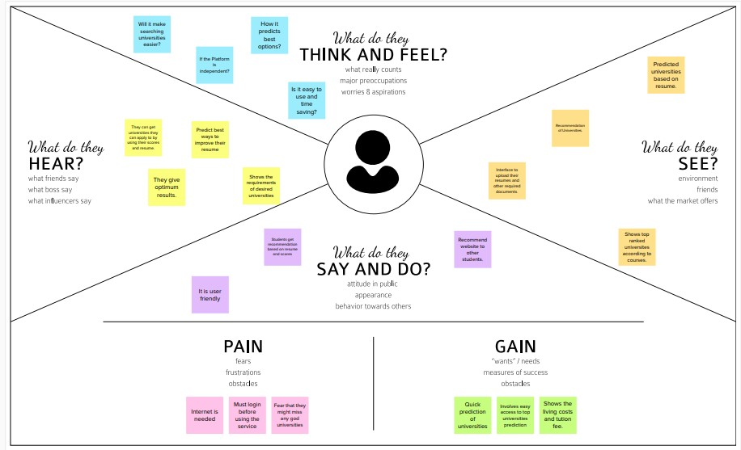

## Ideation & Brainstorming

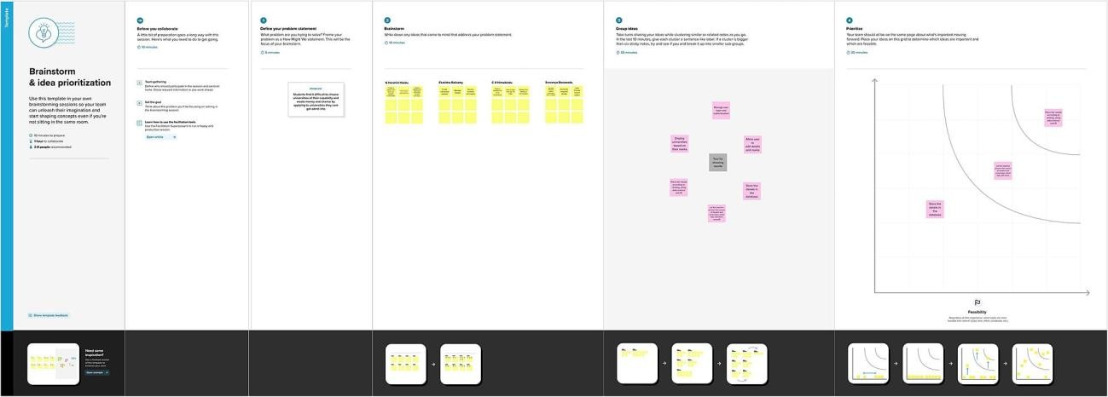

* 1. **Proposed Solution**

1. Problem Statement(Problem to be solved) Students find it difficult to
   * Find universities to study abroad.
   * Choose universities they can afford.
   * Choose universities which are top in field of interest.
   * Know the chances of getting admitted into universities of their

choice.

* + Find guidance to crack universities of their aim.

1. Idea / Solution description

We provide a solution to that problem.Our website incorporates an AI Model that was built after considering many leading Machine Learning Algorithms, to provide the most accurate prediction of how much of a chance of admissions does a student’s current grades and other academic transcripts allow them in the tier of universities of their choice but also we provide a single platform that documents all the requirements as well as the different tiers of universities.

1. Novelty / Uniqueness
   * Web application that allows users to enter their academic data
   * Integration of email alerting system
   * Add filters to search needed information about colleges
   * A search tool that can predict universities
   * Display final results to the student
   * Categorisation and disclosure of living expenses
2. Social Impact / Customer Satisfaction
   * This system is needed so as to answer the queries of students in a compete and concise manner as well as to provide them an as accurate as possible analysis of their chances of admissions to their

dream universities.

* + Users can have a detailed list of all universities.

1. Business Model (Revenue Model)
   * The application can be used in by every aspiring student where the significance of knowing their best choice is understood to be important there by serving as a good business model.
2. Scalability of the Solution
   * The application can be scaled around every earning individual who wants to study abroad.
     + Also, scalability can extend around people working especially in consultancy sectors who pay higher grade of taxes.

## Problem Solution fit

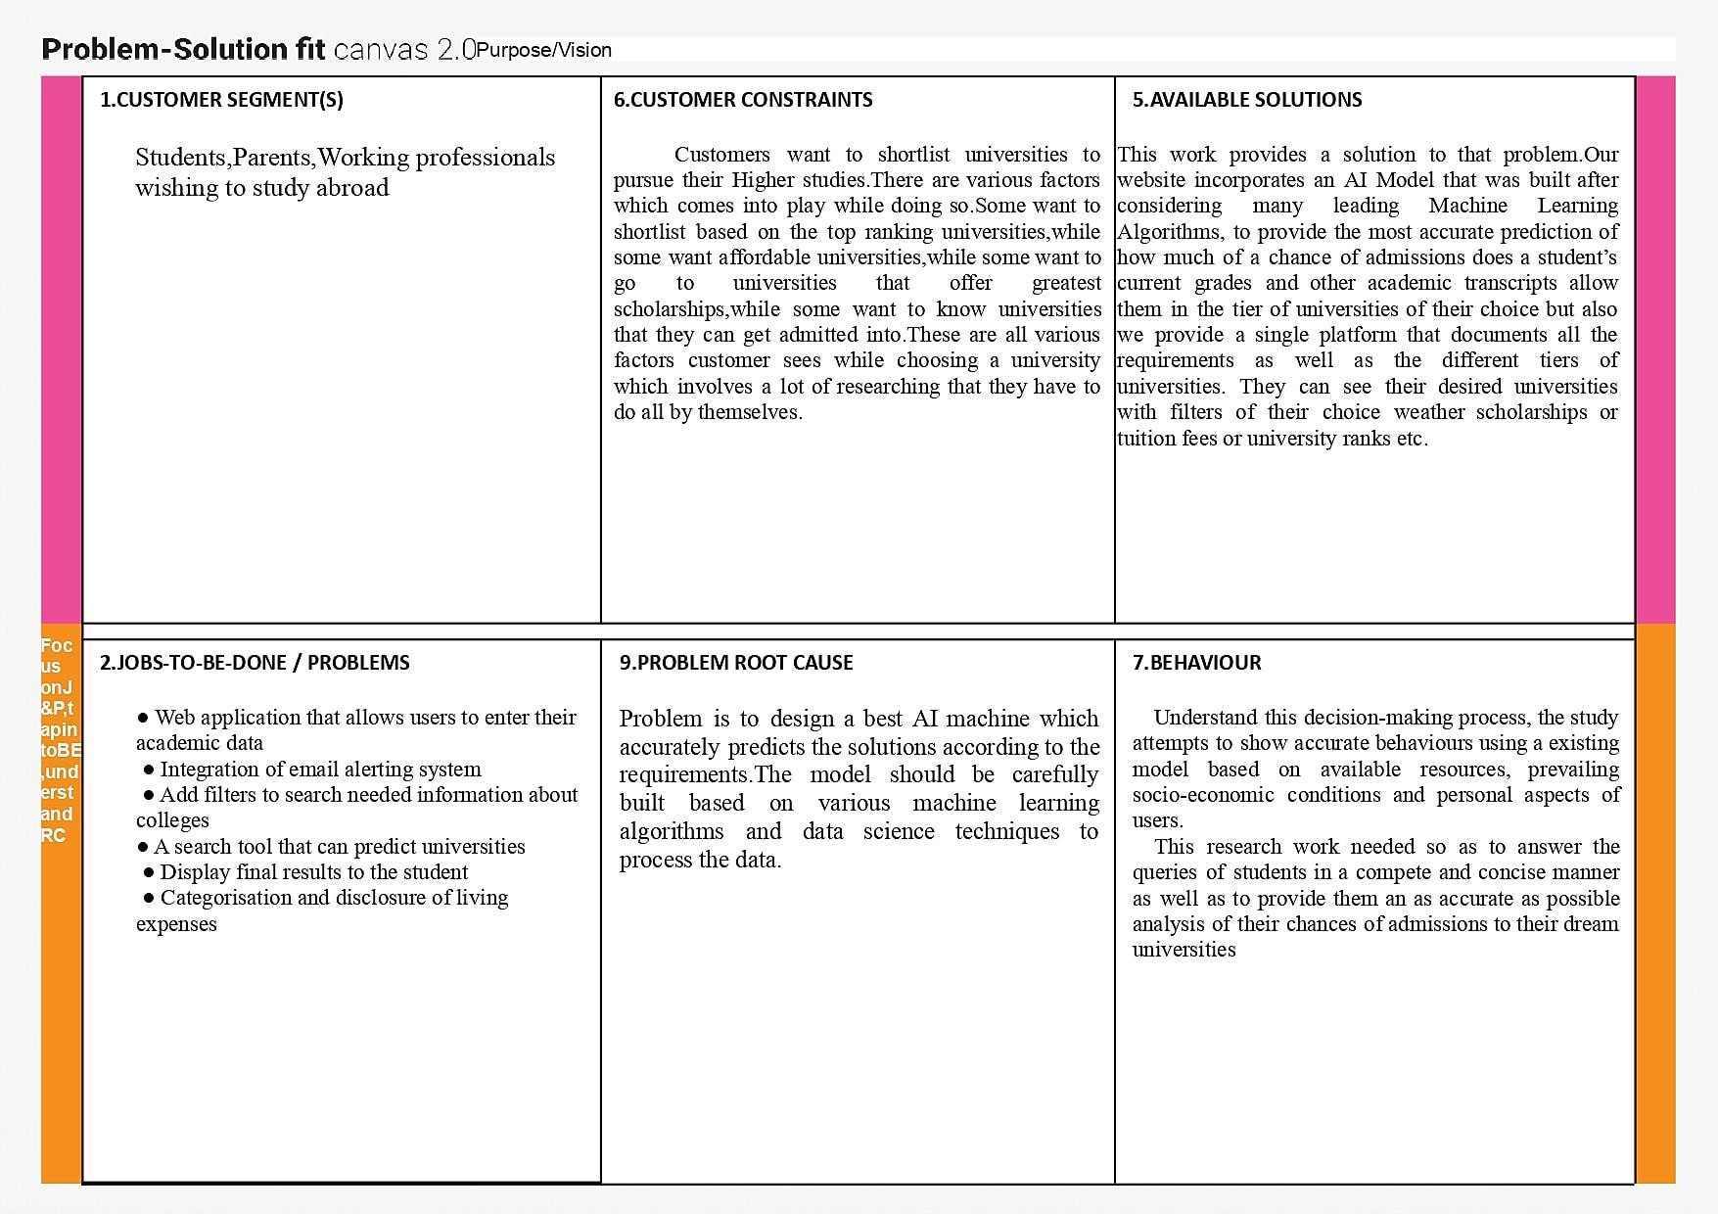

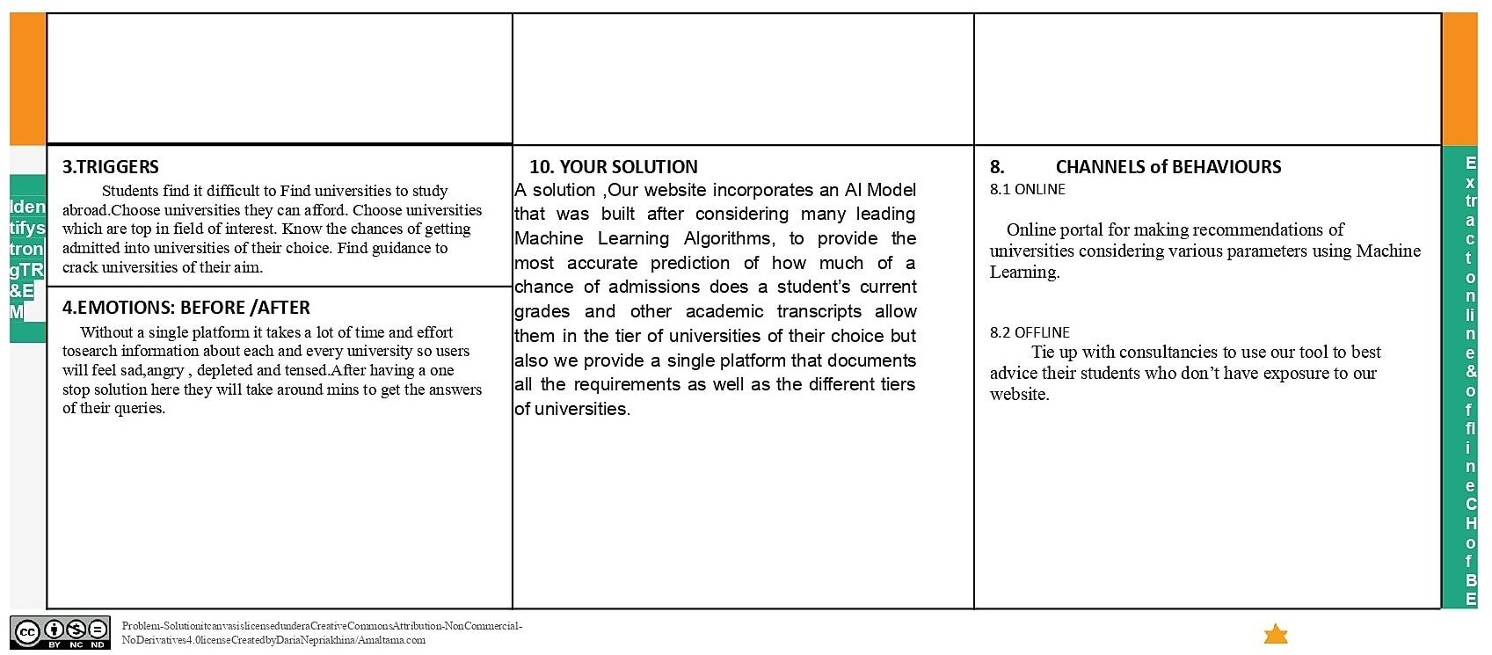

1. **REQUIREMENT ANALYSIS**

## Functional requirement

Following are the functional requirements of the proposed solution.

|  |  |  |
| --- | --- | --- |
| **FR No.** | **Functional Requirement(Epic)** | **Sub Requirement(Story/Sub-Task)** |
| FR-1 | User Registration | Registration through Form Registration through Gmail Registration through LinkedIn |
| FR-2 | User Confirmation | Confirmation via Email Confirmation via OTP |
| FR-3 | User Requirements | All the needed files are been asked to feed in the website.  Based on the uploads, the system would collect all the necessary information.  The information includes the list of all the possible universities and streams. |
| FR-4 | User Details | Has to feed some documents Score Sheets  Letter of Recommendation (LOR) Statement of Purpose (SOP) Curriculum Vitae (CV) |

## Non-Functional requirements

Following are the non-functional requirements of the proposed solution.

|  |  |  |
| --- | --- | --- |
| **NFR No.** | **Non-Functional Requirement** | **Description** |
| NFR-1 | **Usability** | Our website is very user friendly.  There is no need for any technical skill in order to access our website.  The page would not take a lot of time to load the content. |
| NFR-2 | **Security** | The user who is having the valid credentials can able to access our site.  Under any error, the system should be able to come  back to regular operation in under an hour |
| NFR-3 | **Reliability** | The user who is having the valid credentials can able to access our site.  Under any error, the system should be able to come  back to regular operation in under an hour |
| NFR-4 | **Performance** | User can able to access in our website with internet connection.  Traffics can be handled effectively. |
| NFR-5 | **Availability** | Fast and efficient.  Students can access our website from any of the available browser. |
| NFR-6 | **Scalability** | a sizable number of users be able to access the system at the same time.  It must therefore be able to manage numerous concurrent users. |

## PROJECT DESIGN

* 1. **Data Flow Diagrams**

A Data Flow Diagram (DFD) is a traditional visual representation of the information flows within a system. A neat and clear DFD can depict the right amount of the system requirement graphically. It shows how data enters and leaves the system, what changes the information, and where data is stored.

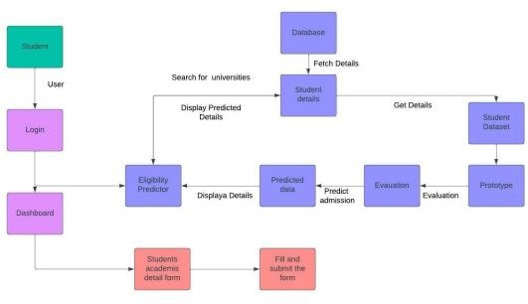

## Solution & Technical Architecture

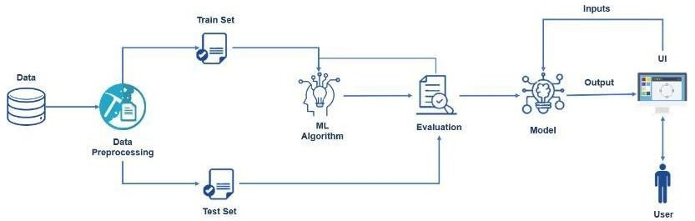

* 1. **User Stories**

|  |  |  |  |  |  |  |
| --- | --- | --- | --- | --- | --- | --- |
| **User Type** | **Functional**  **Requirement (Epic)** | **User Story Number** | **User Story /Task** | **Acceptance criteria** | **Priority** | **Release** |
| Customer (web user) | Login | USN-1 | As a user, I can login and enter the dashboard | I can access my account / dashboard | High | Sprint-1 |
|  |  | USN-2 | As a user, If i did not have a login first i sign up  and then i can access  the features. | I can receive mail for confirmation when i sign up and once login i can access the website | High | Sprint-1 |
|  | Dashboard | USN-3 | I can view the list of  university | I can view the available  university details | High | Sprint-1 |
|  |  | USN-4 | I can search for a  particular university | I can view the details of  the particular university | Medium | Sprint-2 |
|  |  | USN-5 | I can access the  academic details form | I can enter the academic details and submit the form | High | Sprint-2 |
|  | Prediction | USN-6 | I can see the eligibility of the  particular university which i like to join | with the help of dataset it shows the predicted result | High | Sprint-3 |
|  |  | USN-7 | I can see the eligible universities based on my academic scores | Shows the list of universities which is based on my academic scores | High | Sprint-3 |
|  |  | USN-8 | I can apply for the particular university i want. | I can apply for the university through the provided link | High | Sprint-3 |

## PROJECT PLANNING & SCHEDULING

* 1. **Sprint Planning & Estimation**

|  |  |  |  |  |  |  |
| --- | --- | --- | --- | --- | --- | --- |
| **Sprint** | **Functional Requirement**  **(Epic)** | **User Story**  **Number** | **User Story/Task** | **Story Points** | **Priority** | **Team Members** |
| Sprint-1 | Login | USN-1 | As a user, I can log into the application by entering email & password | 3 | High | G Harshini Naidu CH Himabindu Bezawada Sai Sravanya  Ekshitha Balisetty |

|  |  |  |  |  |  |  |
| --- | --- | --- | --- | --- | --- | --- |
| Sprint-1 | Saving data to database | USN-2 | The data will be stored to database | 3 | High | G Harshini Naidu CH Himabindu Bezawada Sai Sravanya  Ekshitha Balisetty |
| Sprint-2 | Rate the university | USN-3 | As a user, I will be able to enter the rating of university of my requirement | 5 | High | G Harshini Naidu CH Himabindu Bezawada Sai  Sravanya Ekshitha Balisetty |
| Sprint-2 | Rate the SOPs,LORs | USN-4 | As a user, I will be able to enter the rating of my SOPs and LORs | 2 | Medium | G Harshini Naidu CH Himabindu Bezawada Sai Sravanya Balisetty  Ekshitha |
| Sprint-2 | Enter the scores of Exams GRE,TOEFL | USN-5 | As a user, I will be able to enter the scores | 2 | Medium | G Harshini Naidu CH Himabindu Bezawada Sai Sravanya  Balisetty Ekshitha |
| Sprint-3 | Creating the model | USN-6 | An admin,will be creating the Model to predict the yes or no chances | 3 | High | G Harshini Naidu CH Himabindu Bezawada Sai Sravanya Balisetty Ekshitha |
| Sprint-3 | prediction | USN-7 | As a admin, I can test the trained machine learning model by analysing the user details by machine learning algorithms like logistic  regression | 3 | High | G Harshini Naidu CH Himabindu Bezawada Sai Sravanya |
| Sprint-4 | Chance of getting into univeristies | USN-8 | As a admin, The model is created to show if the chances are present or not. | 2 | High | G Harshini Naidu CH Himabindu Bezawada Sai Sravanya  Balisetty Ekshitha |
| Sprint-4 | Output | USN-9 | As a admin, I can upload the confirmation of user for the prediction into the database. | 3 | High | CH Himabindu Bezawada Sai Sravanya Balisetty Ekshitha |
| Sprint-4 | Displaying the results | USN-10 | The user will be able to see if his chances are positive or negative | 5 | High | G Harshini Naidu CH Himabindu Bezawada Sai Sravanya  Balisetty Ekshitha |

## Sprint Delivery Schedule

|  |  |  |  |  |  |  |
| --- | --- | --- | --- | --- | --- | --- |
| **Project Tracker** | **Total Story Points** | **Duration** | **Sprint Start Date** | **Sprint End Date(Planned)** | **Story Points Completed( as on planned End**  **Date)** | **Sprint Release Date**  **(Actual)** |
| Sprint-1 | 20 | 6 Days | 24 Oct 2022 | 29 Oct 2022 | 20 | 29 Oct 2022 |
| Sprint-2 | 20 | 6 Days | 31 Oct 2022 | 05 Nov 2022 | 20 | 05 Nov 2022 |
| Sprint-3 | 20 | 6 Days | 07 Nov 2022 | 12 Nov 2022 | 20 | 12 Nov 2022 |
| Sprint-4 | 20 | 6 Days | 14 Nov 2022 | 19 Nov 2022 | 20 | 19 Nov 2022 |

1. **CODING & SOLUTIONING**
   1. **Feature 1**

User should enter their GRE Score, TOFEL Score, University Rating, SOP, and the rating of LOR and the CGPA of their Academics. In addition to this one should also enter whether they have published any Research Paper or not. By filling all these details the user can know whether he or she is eligible for the application or not. By analyzing all the given details the application predicts the chance of getting admitted to the universities.

# Index.html

<!DOCTYPEhtml>

<htmllang="en">

<head>

<metacharset="UTF-8">

<metahttp-equiv="X-UA-Compatible"content="IE=edge">

<metaname="viewport"content="width=device-width, initial-scale=1.0">

<metaname="viewport"content="width=device-width, initial-scale=1, maximum- scale=1, user-scalable=no">

<linkrel="stylesheet"type="text/css"rel="noopener"target="_blank"href="../static/ css/styles.css">

<linkhref=["https://cdn.jsdelivr.net/npm/bootstrap@5.2.2/dist/css/bootstrap.min.cs](https://cdn.jsdelivr.net/npm/bootstrap%405.2.2/dist/css/bootstrap.min.cs) s"rel="stylesheet"integrity="sha384-

Zenh87qX5JnK2Jl0vWa8Ck2rdkQ2Bzep5IDxbcnCeuOxjzrPF/et3URy9Bv1WTRi"crossorigin="ano nymous">

<scripttype="text/javascript"src="../static/js/script.js"async></script>

<title>University Admit Eligibility Predictor</title>

</head>

<body>

<navclass="navbar navbar-expand-lg bg-light">

<divclass="container-fluid">

<aclass="navbar-brand text-responsive-h" href="/">

<imgsrc="..\static\image\hat1.png"alt="Logo"width="30"height="24"class="d-inline- block align-text-top ">

University Admit Eligibility Predictor

</a>

</div>

</nav>

{% block body %}

<h1> Index Page </h1>

{% endblock %}

<scriptsrc=["https://cdn.jsdelivr.net/npm/bootstrap@5.2.2/dist/js/bootstrap.bundle](https://cdn.jsdelivr.net/npm/bootstrap%405.2.2/dist/js/bootstrap.bundle)

.min.js"integrity="sha384- OERcA2EqjJCMA+/3y+gxIOqMEjwtxJY7qPCqsdltbNJuaOe923+mo//f6V8Qbsw3"crossorigin="ano nymous"></script>

</body>

</html>

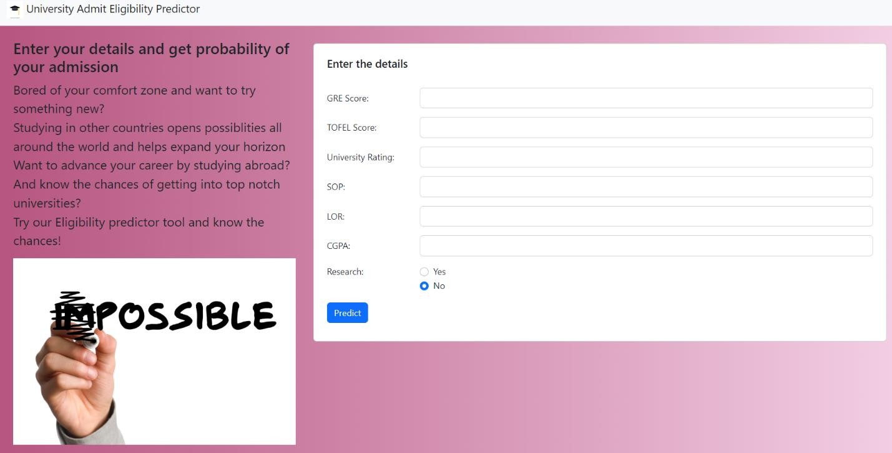

# Demo2.html

{% extends 'index.html' %}

{% block body %}

<divclass="p-4">

<divclass="row mb-3">

<divclass="col-4">

<h2 class="text-responsive-h">

Enter your details and get probability of your admission

</h2>

<p class="text-responsive">

Bored of your comfort zone and want to try something new?<br>

Studying in other countries opens possiblities all around the world and helps expand your horizon<br>

Want to advance your career by studying abroad?<br>

And know the chances of getting into top notch universities?<br> Try our Eligibility predictor tool and know the chances!<br>

</p>

<divclass="d-flex justify-content-right">

<imgsrc="../static/image/yesno.jpg"class="card-img-

top"alt="..."/>

</div>

</div>

<divclass="col-8">

<divclass="card p-2 ms-2 my-2">

<divclass="card-body">

<h5class="card-title pb-4"> Enter the details

</h5>

<formaction="/"method="post"id="theForm">

<divclass="row mb-3">

<labelfor="gre"class="col-lg-2 col-form-

label">GRE Score:</label>

<divclass="col-lg-10">

<inputtype="number"class="form-

control"id="gre"name="gre"min="250"max="340"required>

</div>

</div>

<divclass="row mb-3">

<labelfor="tofel"class="col-lg-2 col-form-

label">TOFEL Score:</label>

<divclass="col-lg-10">

<inputtype="number"class="form-

control"id="tofel"name="tofel"min="50"max="120"required>

</div>

</div>

<divclass="row mb-3">

<labelfor="university_rating"class="col-lg-2 col- form-label">University Rating:</label>

<divclass="col-lg-10">

<inputtype="number"class="form- control"id="university_rating"step="0.01"name="university_rating"min="1"max="5"re quired>

label">SOP:</label>

</div>

</div>

<divclass="row mb-3">

<labelfor="sop"class="col-lg-2 col-form-

<divclass="col-lg-10">

<inputtype="number"class="form-

control"id="sop"name="sop"step="0.01"min="1"max="5"required>

label">LOR:</label>

</div>

</div>

<divclass="row mb-3">

<labelfor="lor"class="col-lg-2 col-form-

<divclass="col-lg-10">

<inputtype="number"class="form-

control"id="lor"name="lor"step="0.01"min="1"max="5"required>

</div>

</div>

<divclass="row mb-3">

<labelfor="cgpa"class="col-lg-2 col-form-

label">CGPA:</label>

<divclass="col-lg-10">

<inputtype="number"class="form-

control"id="cgpa"name="cgpa"step="0.01"min="5"max="10"required>

</div>

</div>

<fieldsetclass="row mb-3">

<legendclass="col-form-label col-sm-2 pt-

0">Research:</legend>

<divclass="col-sm-10">

<divclass="form-check">

<inputclass="form-check-

input"type="radio"name="yes_no_radio"id="gridRadios1"value="1">

<labelclass="form-check-

label"for="yes_no_radio">

Yes

</label>

</div>

<divclass="form-check">

<inputclass="form-check-

input"type="radio"name="yes_no_radio"id="gridRadios2"value="0"checked>

<labelclass="form-check-

label"for="yes_no_radio">

No

</label>

</div>

</div>

</fieldset>

<divclass="row lg-3">

<divclass="col-lg-2 mb-2 me-3">

<buttontype="submit"class="btn btn-primary"

id="button">Predict</button>

role="status"> hidden">Loading...</span>

role="status"> hidden">Loading...</span>

</div>

<!-- <div class="col-lg-2" id="spinner">

<div class="spinner-border text-primary m-1"

<span class="visually-

</div>

<div class="spinner-grow text-primary m-1"

<span class="visually-

</div>

</div>-->

</form>

</div>

</div>

</div>

</div>

</div>

{% endblock %}

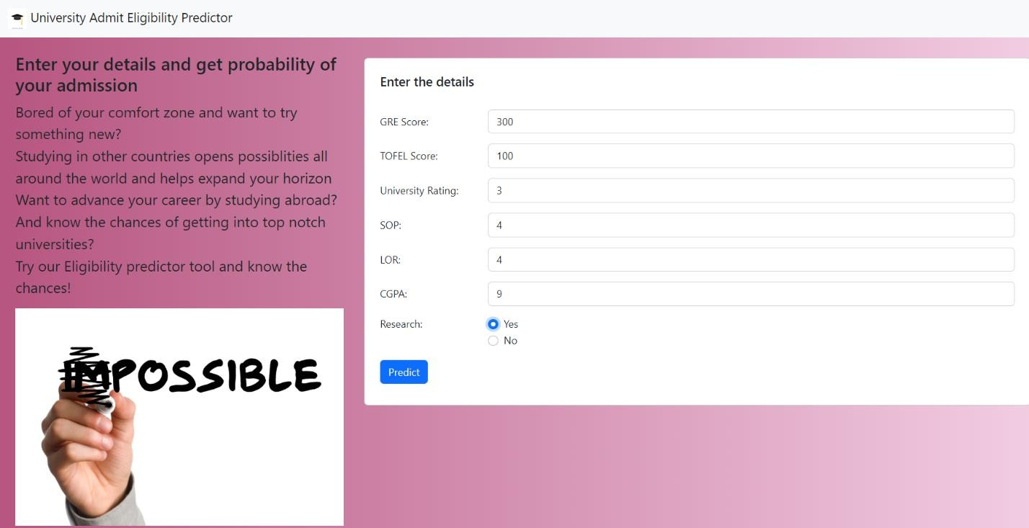

# Chance.html

{% extends 'index.html' %}

{% block body %}

<divclass="container text-center p-4">

<divclass="d-flex justify-content-center">

<divclass="card"style="width: 34rem;">

<imgsrc="..\static\image\chance.png"class="card-img-top"alt="...">

<divclass="card-body">

<h5 class="card-title">You Have Chance</h5>

<p class="card-text">The model has predicted that you have

chance</p>

<a href="/home"class="btn btn-primary">Go Back</a>

</div>

</div>

</div>

</div>

{% endblock %}

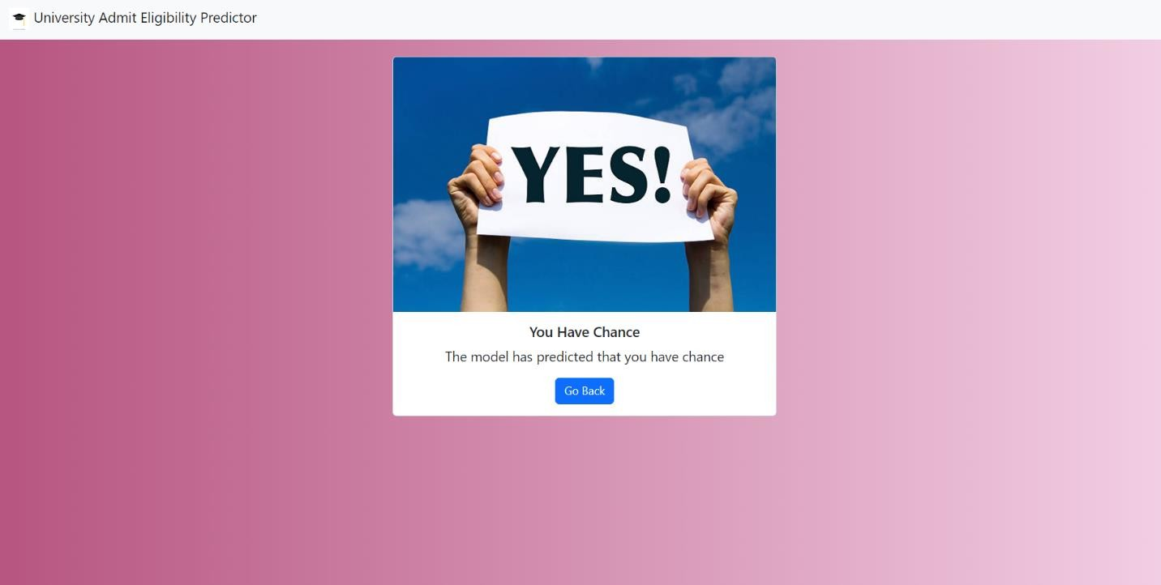

**Nochance.html**

{% extends 'index.html' %}

{% block body %}

<divclass="container text-center p-4">

<divclass="d-flex justify-content-center">

<divclass="card"style="width: 34rem;">

<imgsrc="..\static\image\Nochance.jpg"class="card-img-top"alt="...">

<divclass="card-body">

<h5 class="card-title">You have a LOW / NO chance</h5>

<p class="card-text">The model has predicted that you have no

chance</p>

<a href="/home"class="btn btn-primary">Go Back</a>

</div>

</div>

</div>

</div>

{% endblock %}

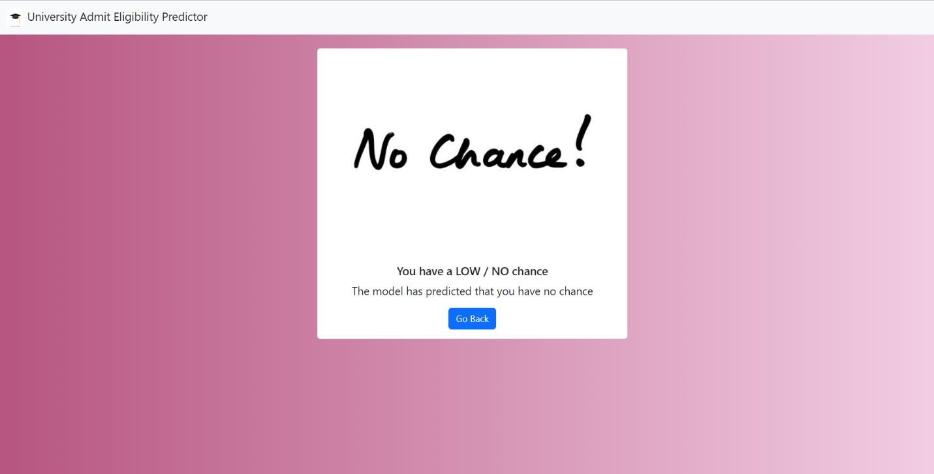

# Style.css

img {

max-width: auto; height: auto;

}

.text-responsive {

font-size: calc(50% + 0.6vw + 0.6vh);

}

.text-responsive-h {

font-size: calc(80% + 0.6vw + 0.6vh);

}

Footer

**Script.js**

const button = document.getElementById('button'); const theForm = document.getElementById('theForm'); const loading = document.getElementById('spinner');

const disableButton = () => { console.log('Submitting form...'); button.disabled = true;

button.className = "btn btn-outline-primary"; button.innerHTML = "Predicting..." loading.style.display = "block"

};

const enableButton = () => { console.log('Loading window...'); button.disabled = false; button.className = "btn btn-primary" button.innerHTML = "Predict" loading.style.display = "none"

}

theForm.onsubmit = disableButton; window.onload = enableButton;

1. **TESTING**
   1. **Test Cases**

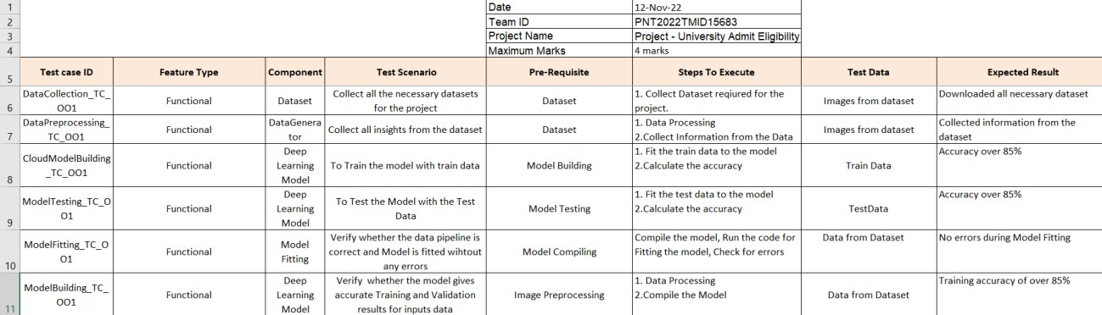

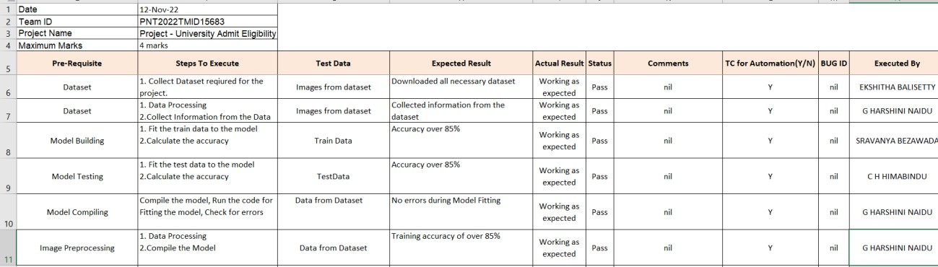

* 1. **User Acceptance Testing**

|  |  |  |
| --- | --- | --- |
| **S. No** | **Test Cases** | **Yes/ No** |
| 1. | Responds in manually drafted rules | yes |
| 2. | Manages multiple users | yes |
| 3. | Users can enter details | yes |
| 4. | Run the Test cases | yes |
| 5. | Learns from real interactions | no |
| 6. | Training via historical data | no |
| 7. | Has decision-making skills | no |

1. **RESULTS**
   1. **Performance Metrics**

## ADVANTAGES

1. No queueing in responses
2. Latest data and requirements are updated
3. Updated to the latest details
4. Easy to enter data and get results

## DISADVANTAGES

* Data cleaning is more challenging
* Frequent Updating
* Miscalculation of data
* Limited entry resources
* Technology and Hacking

## CONCLUSION

This work provides a solution to that problem.Our website incorporates an AI Model that was built after considering many leading Machine Learning Algorithms, to provide the most accurate prediction of how much of a chance of admissions does a student’s current grades and other academic transcripts allow them in the tier of universities of their choice but also we provide a single platform that documents all the requirements as well as the different tiers of universities.

They can see their desired universities with filters of their choice weather scholarships or tuition fees or university ranks etc.

## FUTURE SCOPE

1. The model can be improved as we gain more data about students
2. User can save data of history
3. Data cleaning techniques developed at the data collection
4. To improve the prediction accuracy. An alternative is to use Natural Language Processing methods to evaluate the essays and letters.

## 13. APPENDIX Source code:

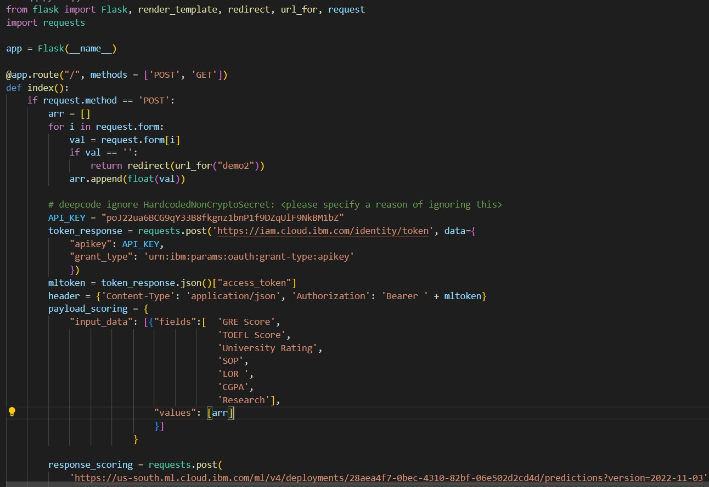

**Git Hub:** <https://github.com/IBM-EPBL/IBM-Project-25308-1659958135>

## Demo link: https://drive.google.com/file/d/1pTB9gfwsm_-bBECM1VK6KQ5duc-D0xbv/view?usp=sharing